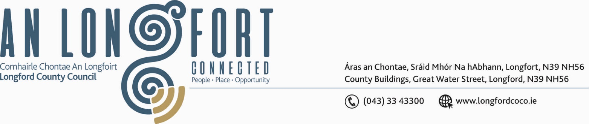

GRANARD MUNICIPAL DISTRICT

17th June 2020

To: Each Member of Granard Municipal District.

A Chomhairleoir,

You are requested to attend the Annual Meeting of Granard Municipal District to be held in Sports Hall, Leisure Centre, Albert Reynolds Peace Park, Longford on Tuesday, 23rd June 2020 at 3.00 p.m. to transact business, as set out on the Agenda hereunder.

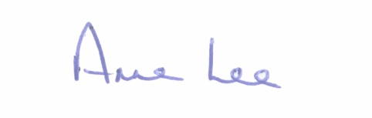
Mise le meas,

_______________
Anne Lee,
Meetings Administrator.

C L A R

1. Election of Cathaoirleach.

2. Election of Leas Cathaoirleach .

3. Fix date and time of Granard Municipal District meetings.



